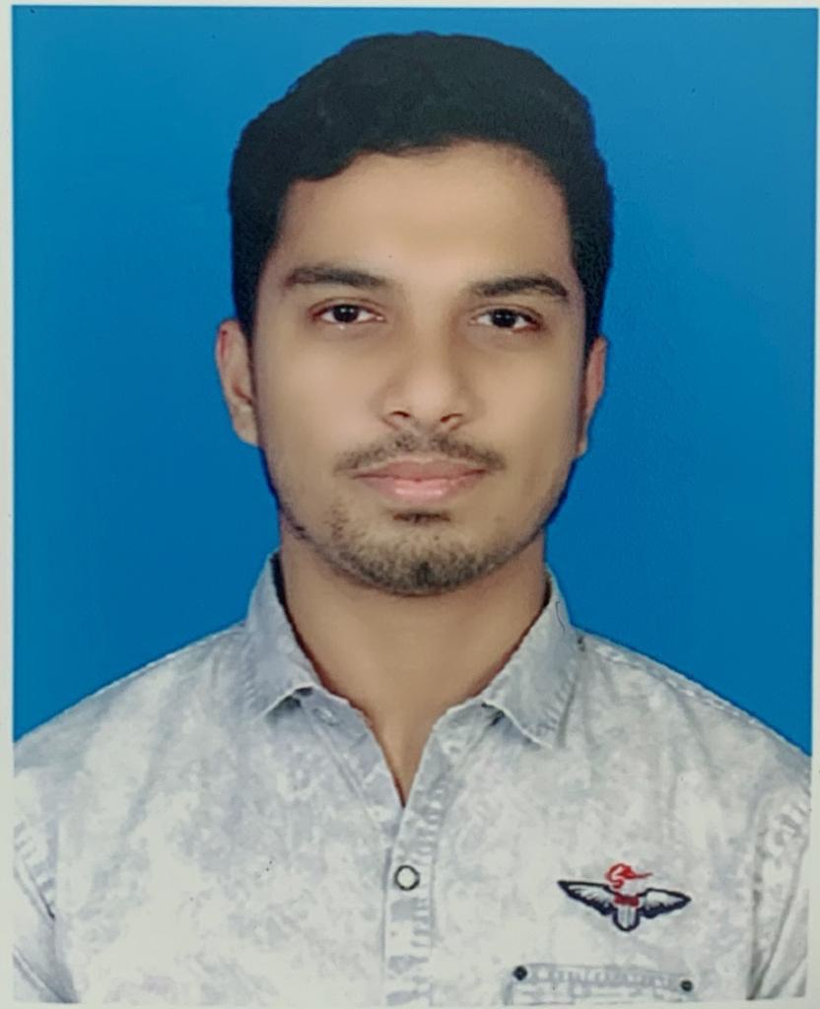FGHGSE

CURICULAM VITAE

**SHAID IBNA SOBHAN**

**PROFILE EDUCATION**

I am a programmer. I also a **Bachelor of Science in CSE**

self-dependent person. University: Patuakhali Science &

Technology University

**SKILLS**

* AutoCAD
* MS Excel
* MS PowerPoint
* Scratch programming
* Visio Drawing

Starting year: 2023

**HSC**

Institute: Motijheel govt. Boys high

school & college

Passing year: 2020

GPA: 5.00

**LANGUAGE SKILLS**

* English
* Hindi
* Arabic

**SSC**

Institute: National Bank Public

School & college

Passing year: 2018

GPA: 5.00

**CONTACT**

**EXTRACURRICULAR ACTIVITIES**

* Volunteer Work
* Arts

Call: 01825809073

Email: [shaidmeheraj9@gmail.com](mailto:shaidmeheraj9@gmail.com)

Location: Moghbazar, Dhaka